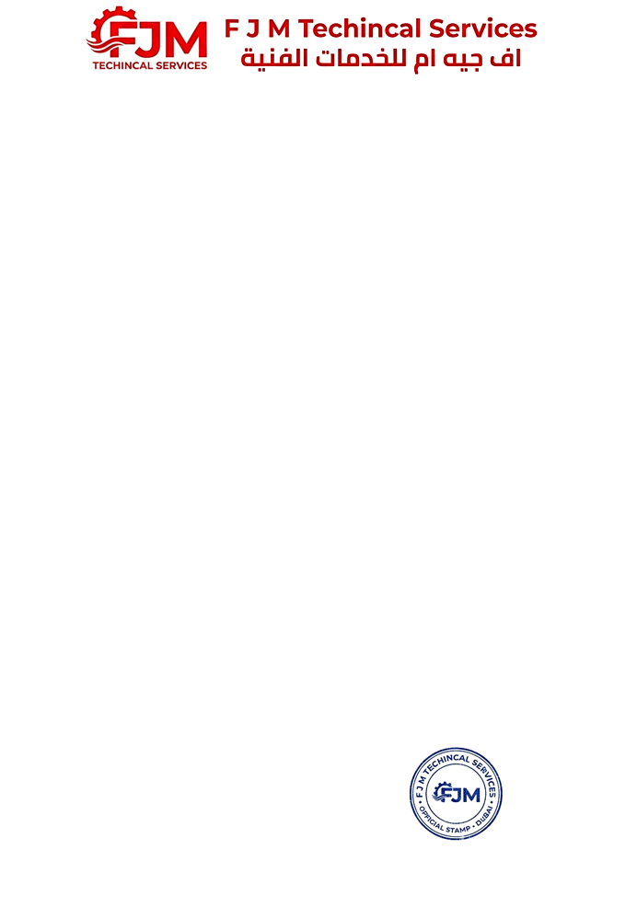
Date: 11-06-2026

Ministory of Human Resource & Emiratisation
DUBAI – UAE

NO OBJECTION CERTIFICATE

We witness F J M TECHINCAL SERVICES, Mr SHEHRYAR ABID ALI a Pakistani national holder of Emirates ID No is 784-2001-2682761-5 under my sponsorship, and we have no objection to issuing him a work permit for any company in UAE according to the laws of United Arab Emirates.

Best Regards,

F J M TECHINCAL SERVICES
DUBAI – UAE


Date: 11-06-2026

Ministory of Human Resource & Emiratisation
DUBAI – UAE

NO OBJECTION CERTIFICATE

We witness SUMMER CITY BUILDING CONTRACTING L.L.C, Mr ASHRAQ AHMED MOHD SHARIF an Indian national holder of Emirates ID No is 784-1981-6592236-4 under my sponsorship, and we have no objection to issuing him a work permit for any company in UAE according to the laws of United Arab Emirates.

Best Regards,

SUMMER CITY BUILDING CONTRACTING L.L.C
DUBAI – UAE

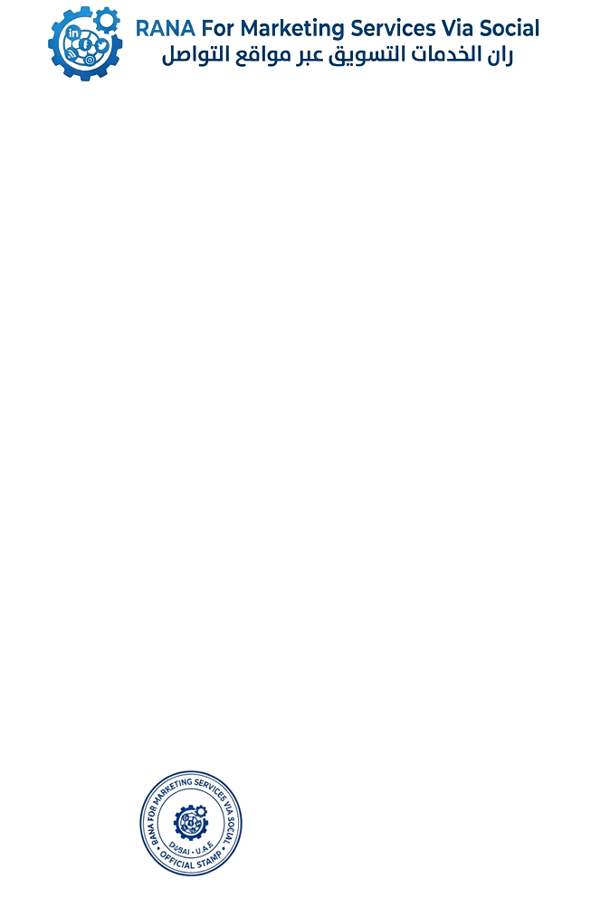
Date: 11-06-2026

Ministory of Human Resource & Emiratisation
DUBAI – UAE

NO OBJECTION CERTIFICATE

We witness RANA FOR MARKETING SERVICES VIA SOCIAL, Mr MUHAMMAD EHTASHAM MUHAMMAD IRSHAD a Pakistani national holder of Emirates ID No is 784-2001-1882604-7 under my sponsorship, and we have no objection to issuing him a work permit for any company in UAE according to the laws of United Arab Emirates.

Best Regards,

RANA FOR MARKETING SERVICES VIA SOCIAL
DUBAI – UAE


Date: 11-06-2026

Ministory of Human Resource & Emiratisation
DUBAI – UAE

NO OBJECTION CERTIFICATE

We witness HASSAN ISHTIAQ TECHINCAL SERVICES L.L.C, Mr SUJAN PAKHRIN a Nepalian national holder of Emirates ID No is 784-2002-7584587-1 under my sponsorship, and we have no objection to issuing him a work permit for any company in UAE according to the laws of United Arab Emirates.

Best Regards,

HASSAN ISHTIAQ TECHINCAL SERVICES L.L.C
DUBAI – UAE

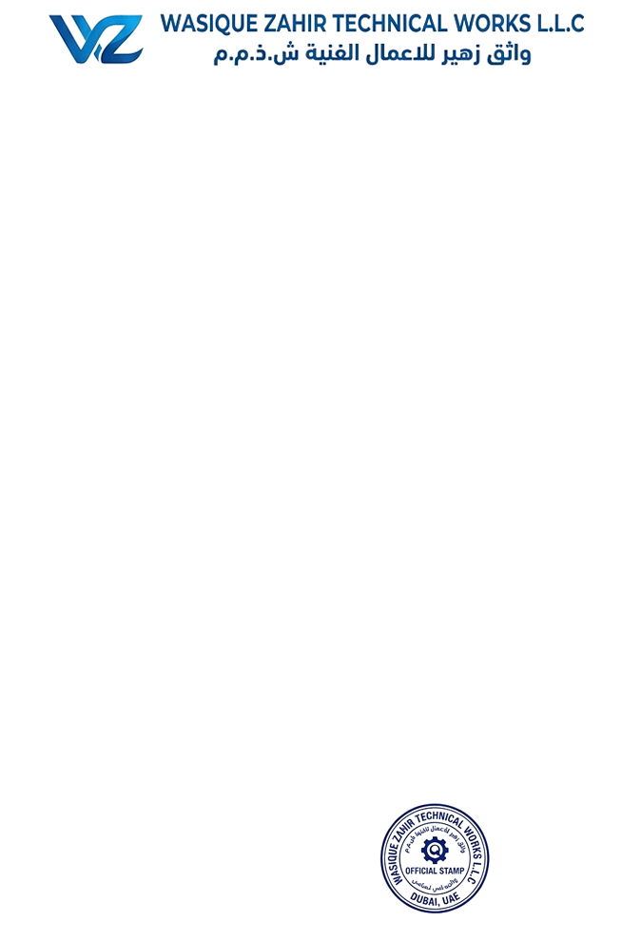
Date: 11-06-2026

Ministory of Human Resource & Emiratisation
DUBAI – UAE

NO OBJECTION CERTIFICATE

We witness WASIQUE ZAHIR TECHINCAL WORKS L.L.C, Mr JABAR HUSSAIN MUHAMMAD KHALID a Pakistani national holder of Emirates ID No is 784-1995-6924737-4 under my sponsorship, and we have no objection to issuing him a work permit for any company in UAE according to the laws of United Arab Emirates.

Best Regards,

WASIQUE ZAHIR TECHINCAL WORKS L.L.C
DUBAI – UAE

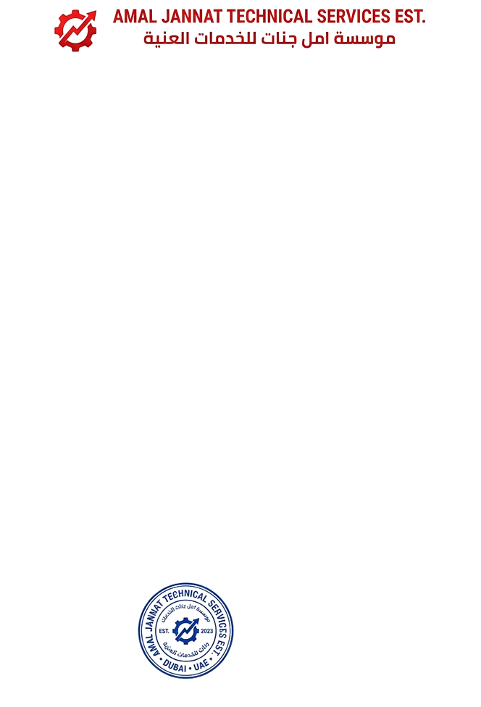
Date: 11-06-2026

Ministory of Human Resource & Emiratisation
DUBAI – UAE

NO OBJECTION CERTIFICATE

We witness AMAL JANNAT TECHNICAL SERVICES EST, Mr SAMI ULLAH MUHAMMAD YOUSAF a Pakistani national holder of Emirates ID No 20020110417800 under my sponsorship, and we have no objection to issuing him a work permit for any company in UAE according to the laws of United Arab Emirates.

Best Regards,

AMAL JANNAT TECHNICAL SERVICES EST
DUBAI – UAE

